**MANOJ KUMAR D THBS-5938**

Use  DQL statements to  print the details of employees  to give the following output:

1. “Name of employee  work in deptno   with the job_Id”  use last_name  coloum
2. Employees who joined in the  year  2000
3. Emploees who joined in  after jan_1996
4. Employess  whose name starts between  ‘S’ to ‘R’
5. Employees who works under manger_id (200,201)
6. Employees who are “REP”(representatives) or “MAN”(salesmans) and who are paid more than 6000
7. Calculate annual salary of each employee and print them in descending order
8. Replace the  last_name  of “Landry”  to “JOE” in the employee table
9. Find the position of first occurance of the character ‘o’  in the last_name  of all employees who have ‘o’  in their last_name.
10. Prefix “2020_B84” for employee last_names who works in department 90
11. Find the current date with local  date and time
12. Find the average commission paid for all  the employees (ignoring the null entries)
13. Find the average  and highest salary paid for department 80,90,100
14. Find the department id    where  the highest paid employee salary is more than 1000.
15. Find the  department id  who is paid the  maximum average salary in the organization: use subqueries
16. Find the departmentname and loacation_id in which ‘Ernst’ work.
17. Find all the employee names who work in “Tokyo” city  ( use subqueries  , table used : employees, departments, locations )
18. Find the employee names who are the maximum paid salary in the organization
19. Find the employees who are drawing minimum salary in their respective departments

(Use the jobs table for getting the min salary and use subquries )

1. Find the employee names and their job_id and job_titles by joining employee and jobs table

1. Select concat(last_name,’ works in dept id ‘,department_id,’, his job id is ‘,job_id) info from employees;

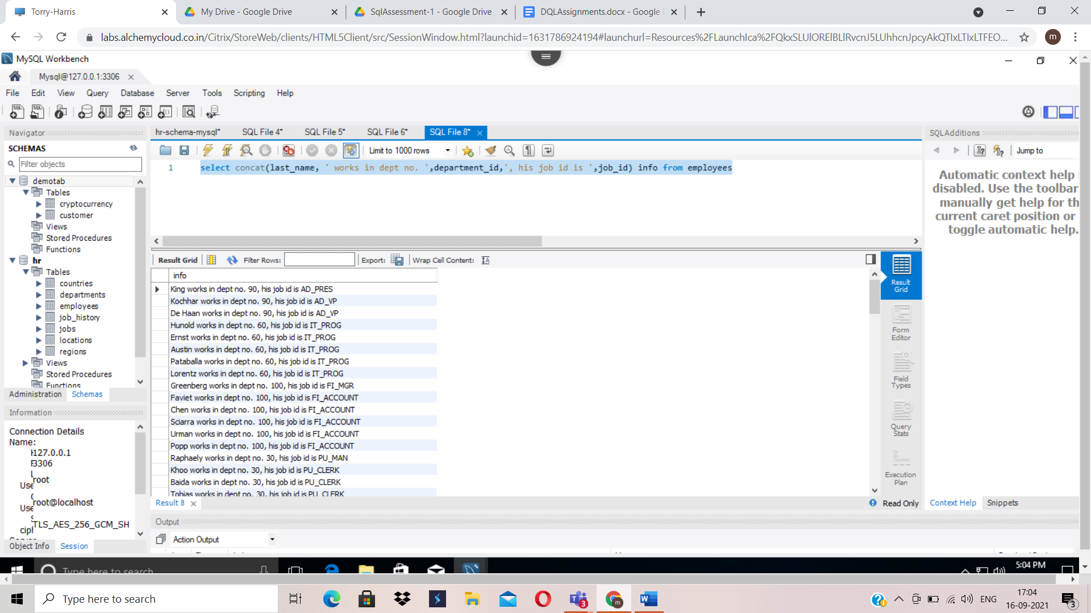

1. Select employee_id, first_name, last_name, hire_date from employees where date_format(hire_date,’%Y’)=2000;

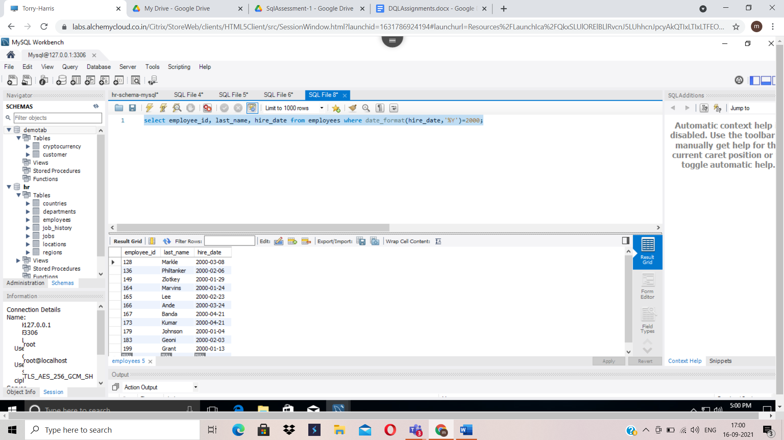

1. Select employee_id, last_name, hire_date from employees where hire_date>’1996-01-31’;

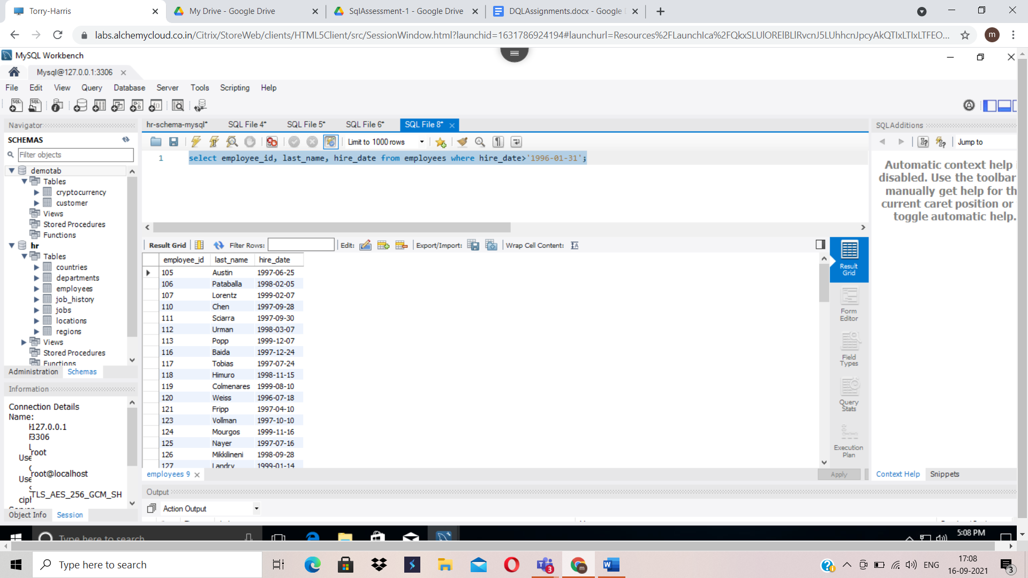

1. select employee_id, first_name from employees where first_name like 'R%' or first_name like 'S%';

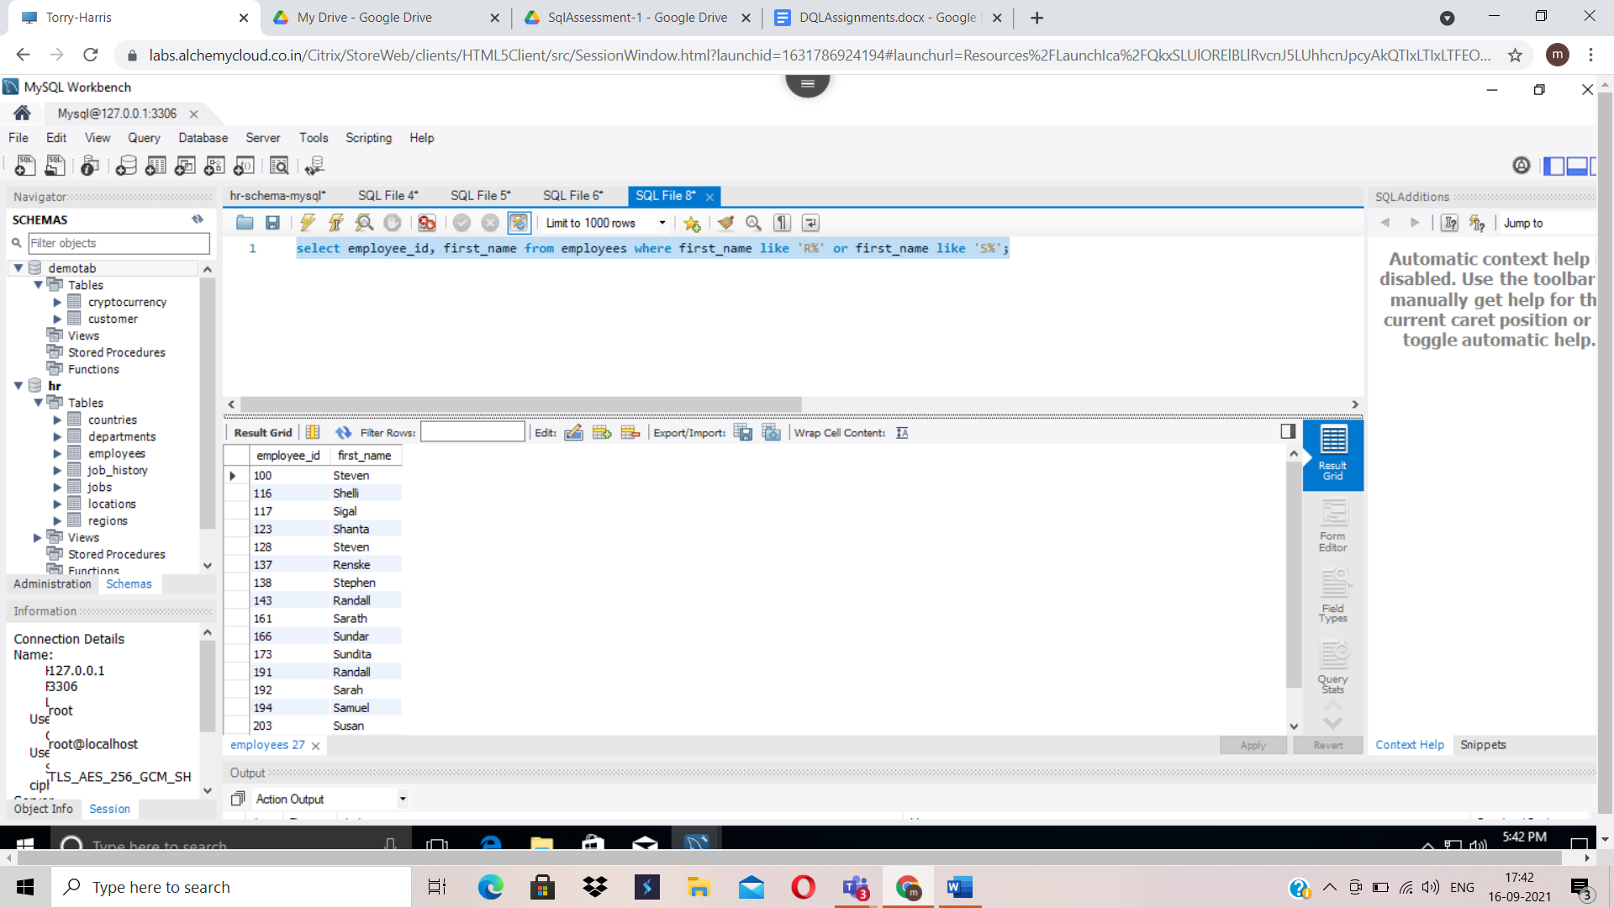

1. select employee_id, last_name, manager_id from employees where manager_id=200 or manager_id=201;

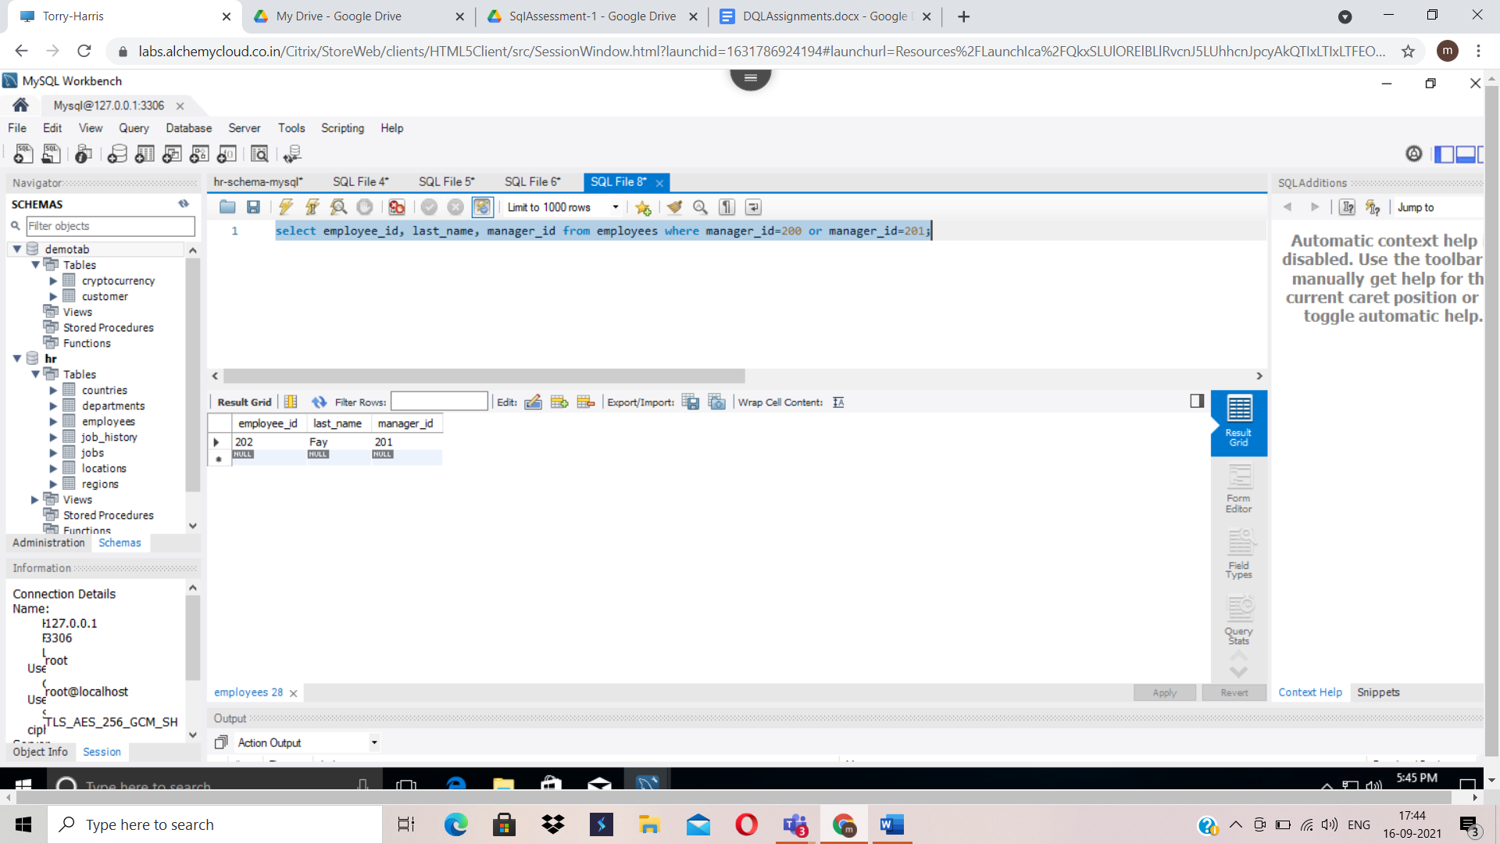

1. select employee_id, last_name, job_id, salary from employees where (job_id like '%REP%' or job_id like '%MAN%') and salary>6000;

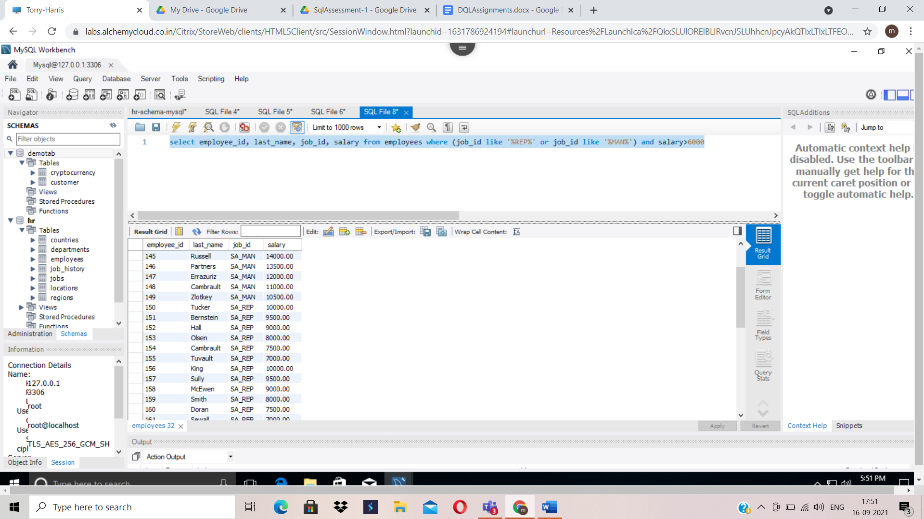

1. select employee_id, last_name, job_id, salary from employees order by salary desc;

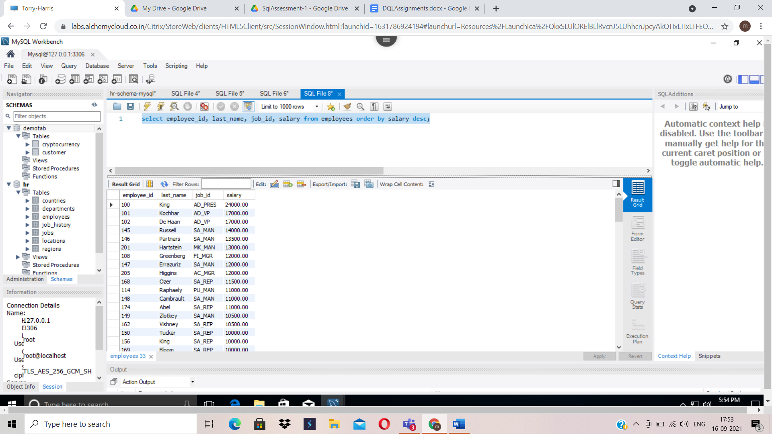

1. select employee_id,replace(last_name,last_name,'Joe'), job_id from employees where last_name='Landry';

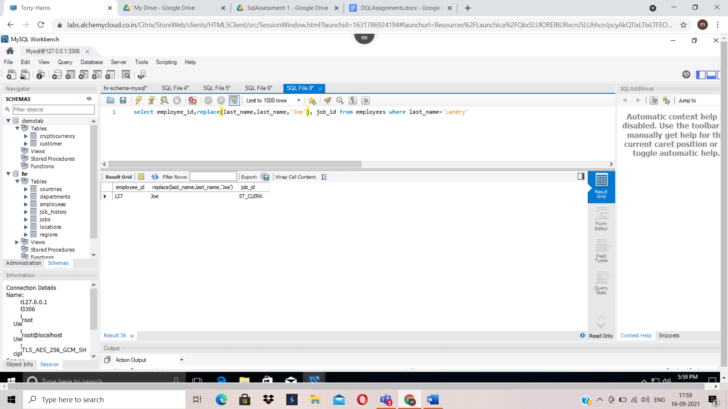

1. select employee_id,instr(lower(last_name),'o') from employees;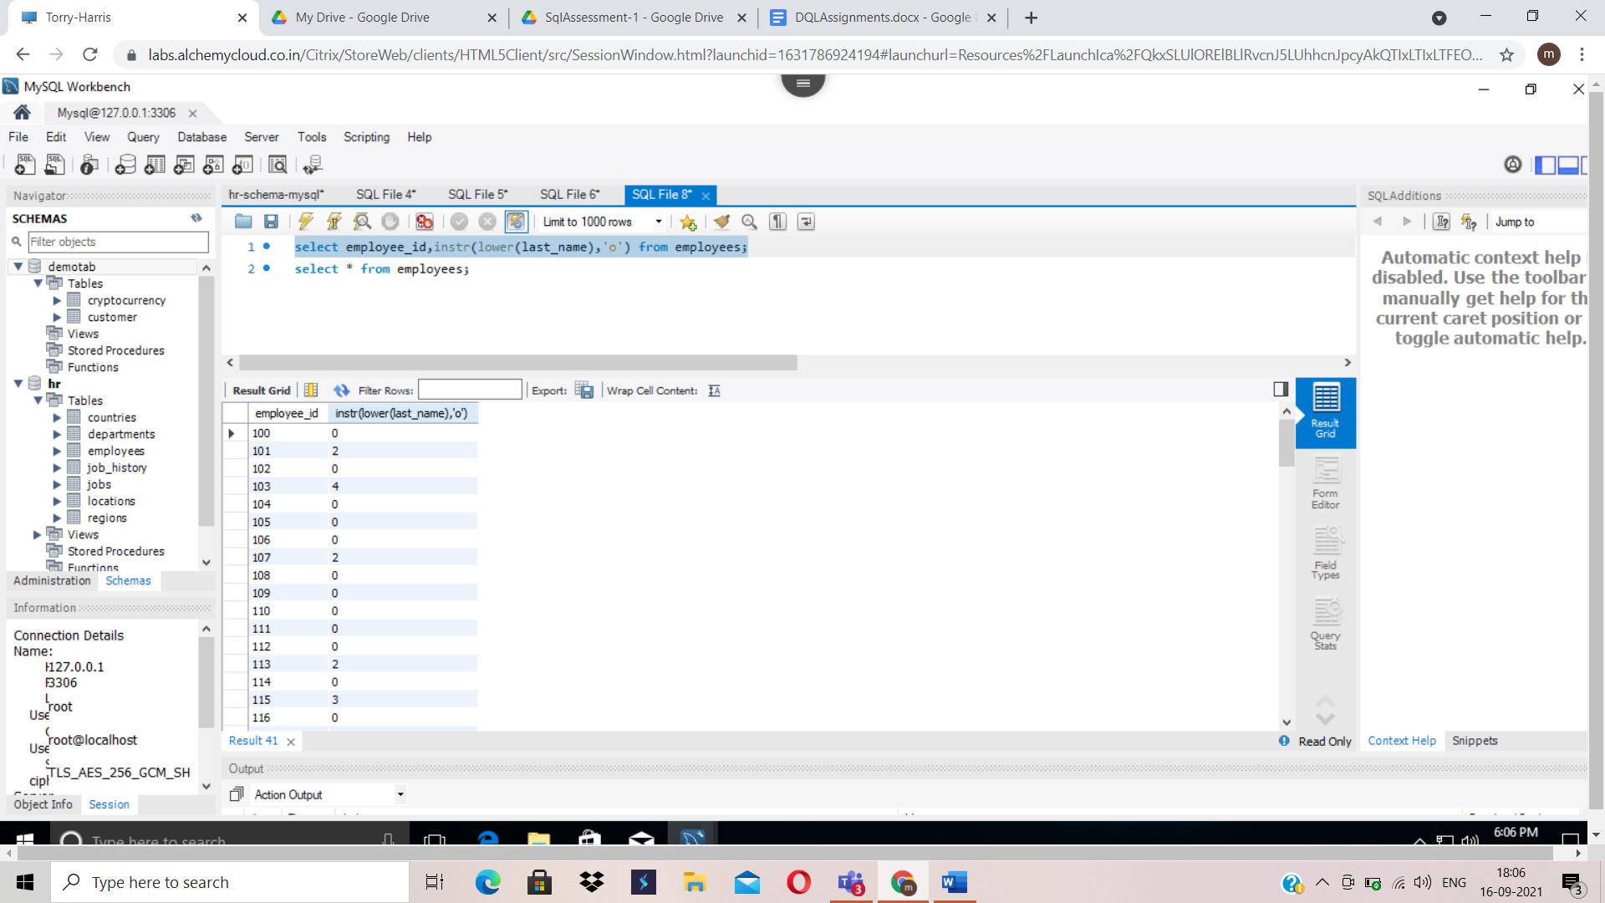
2. select concat('2020_B84',last_name), department_id from employees where department_id=90;

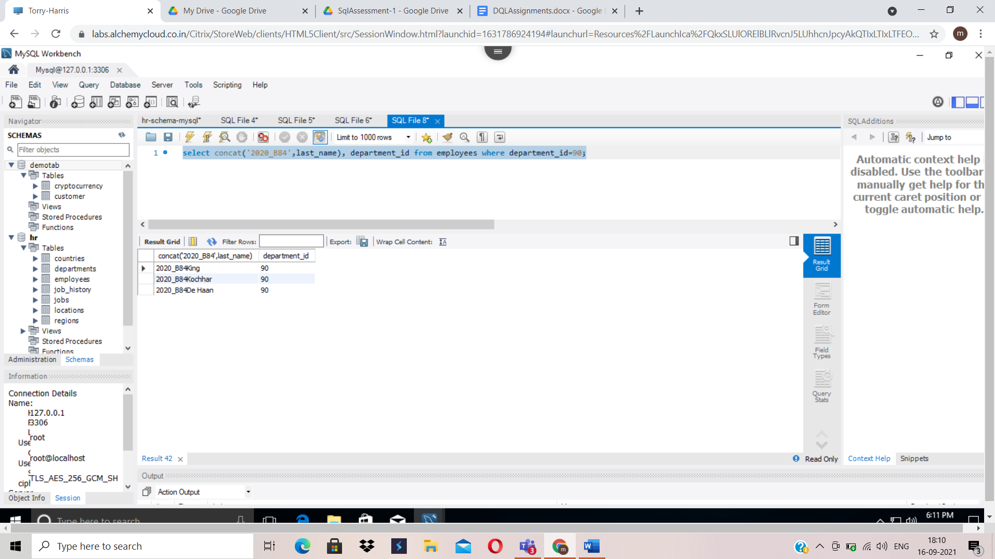

1. Select sysdate();

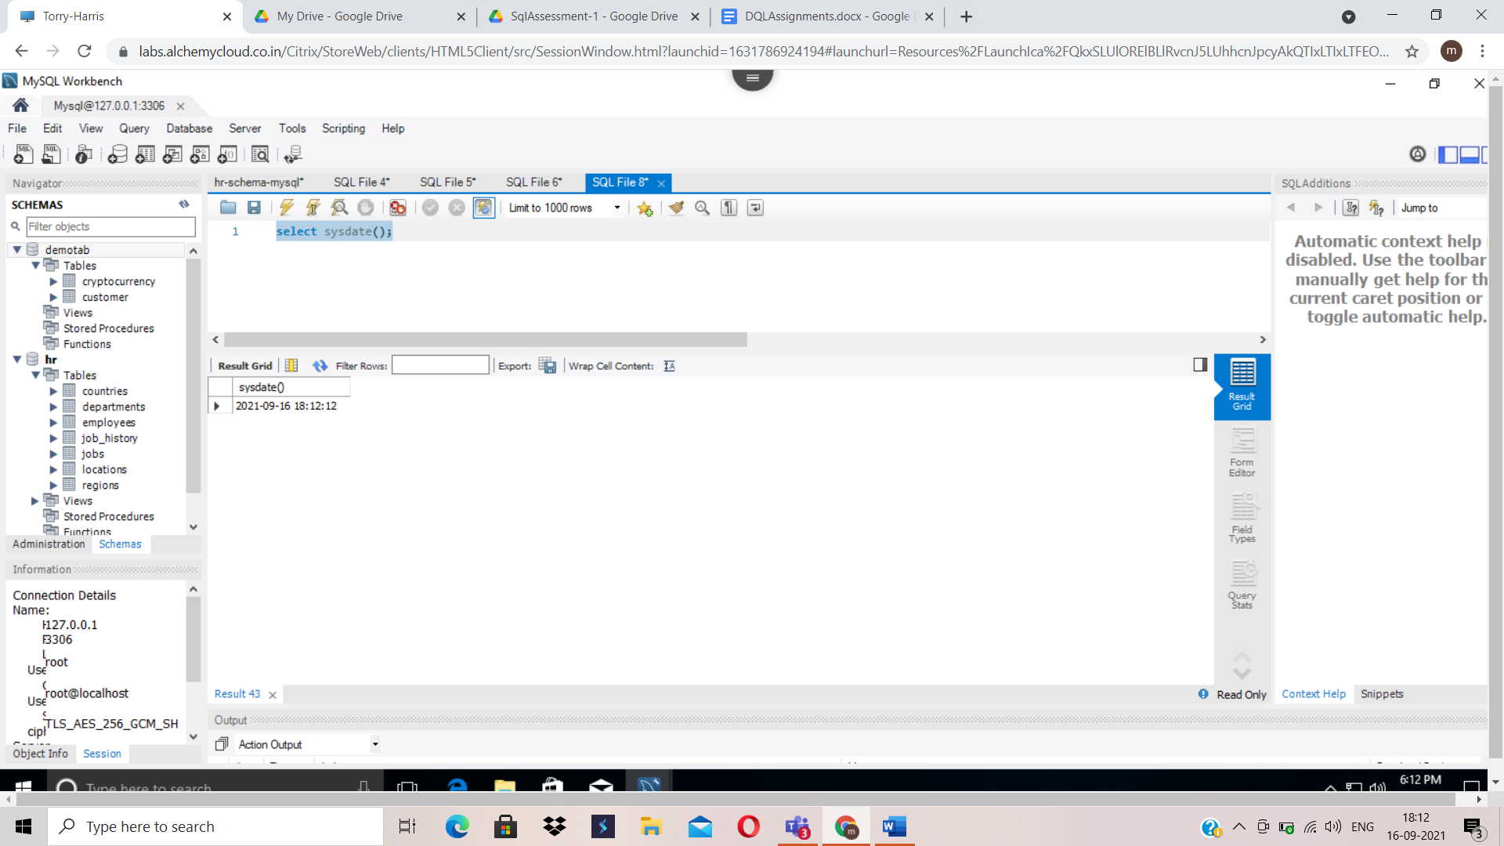

1. select avg(commission_pct) from employees where commission_pct >= 0;

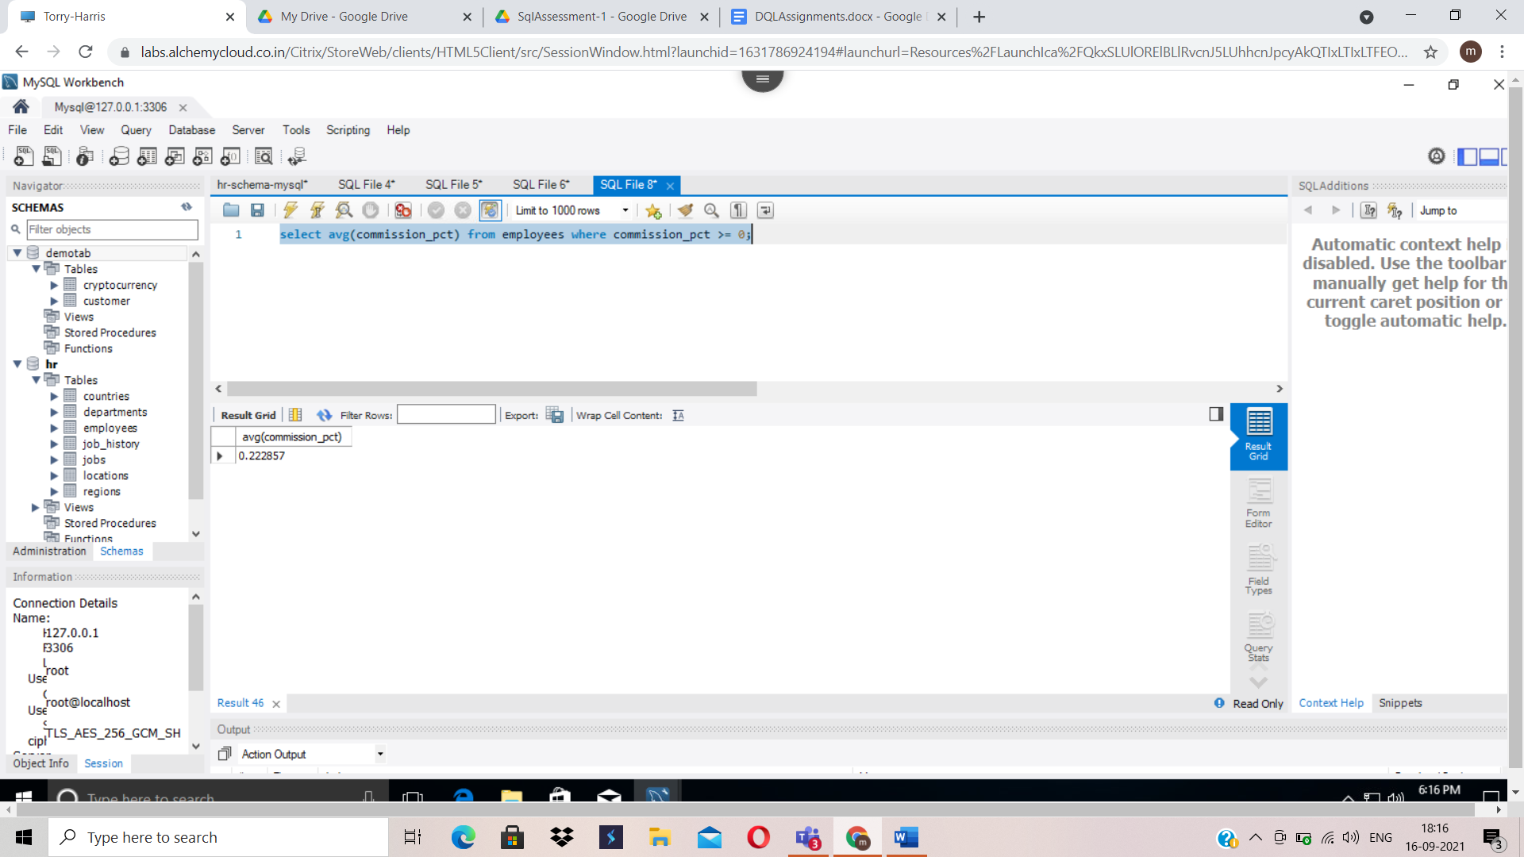

1. select avg(salary), max(salary), department_id from employees group by department_id having department_id >=80 and department_id<=100;

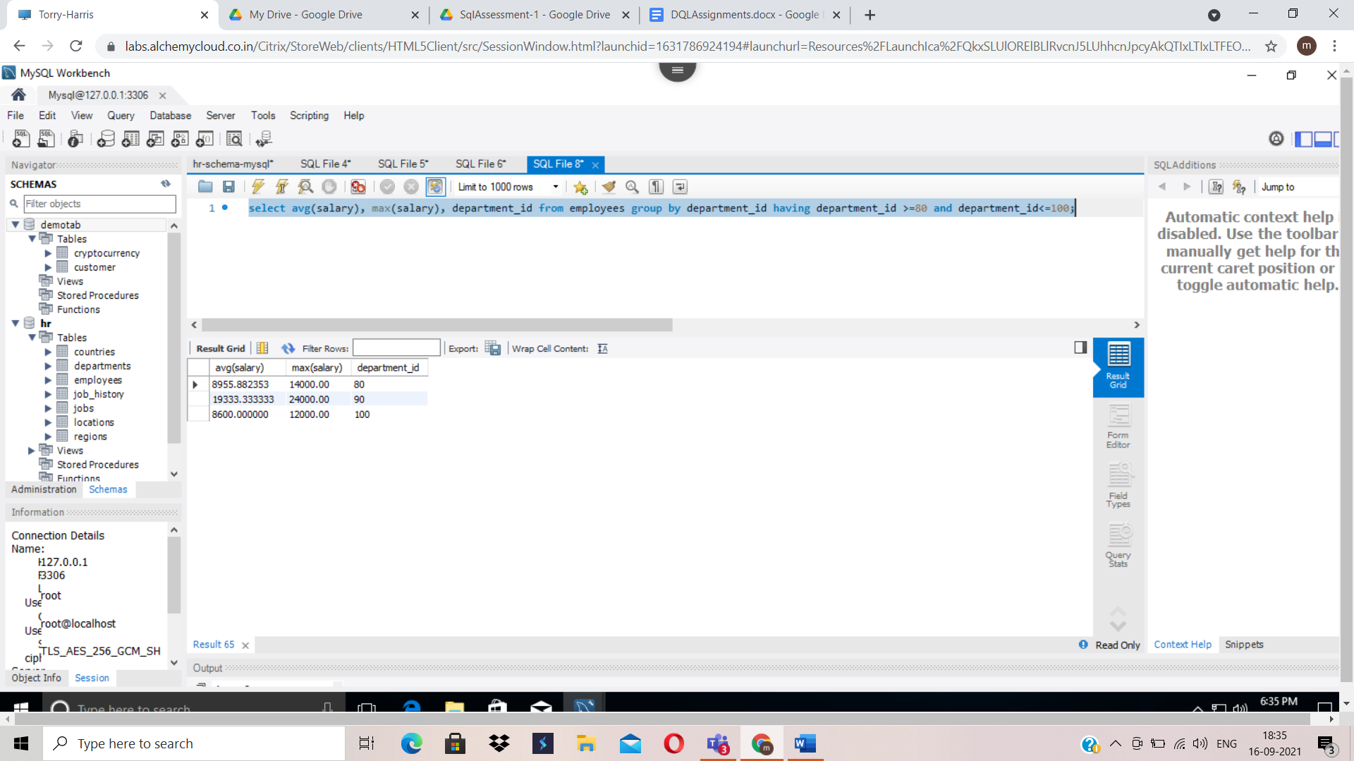

1. Select distinct(department_id) from employees where salary>1000;

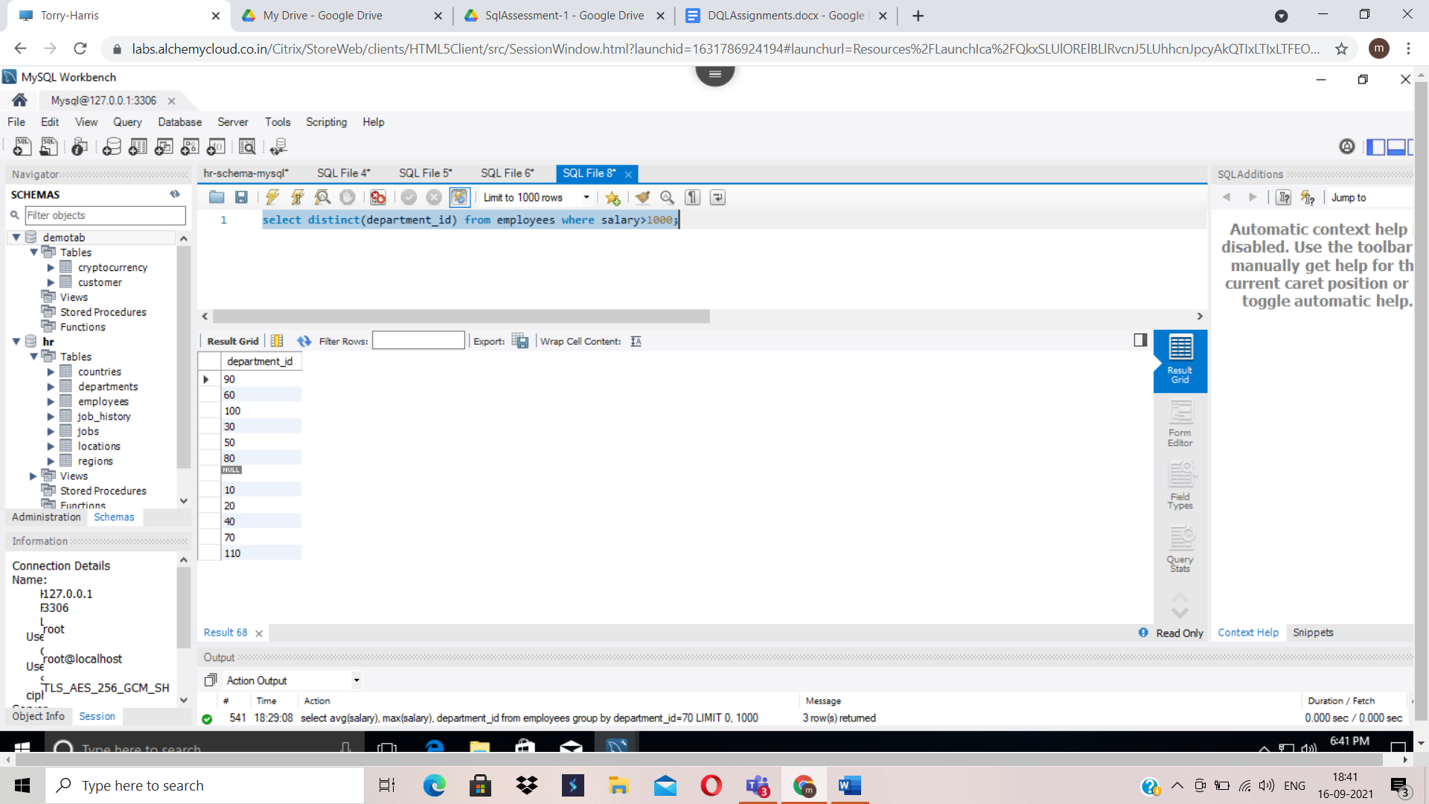

1. select department_id,max(sal) from (select avg(salary) sal, department_id from employees group by department_id)as d;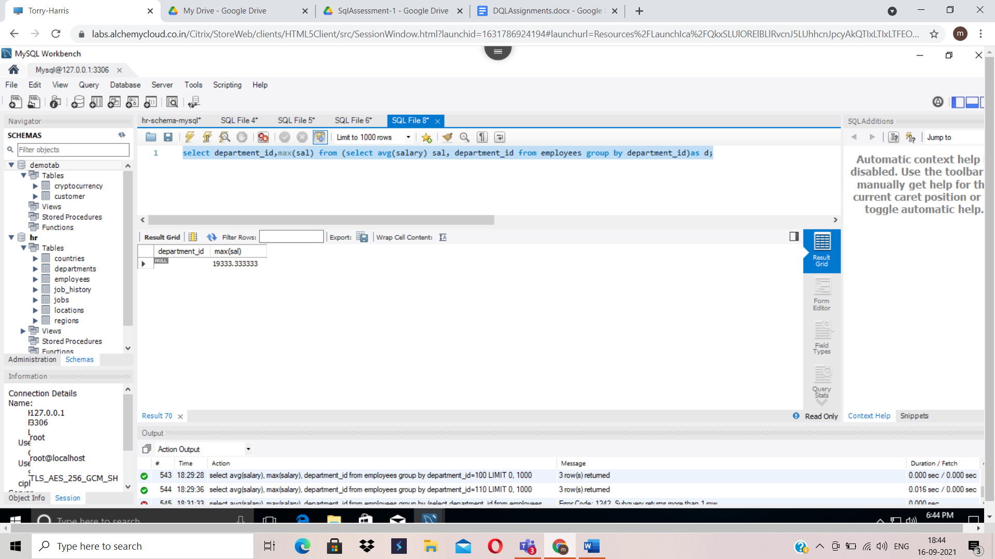

1. select department_name, location_id from departments d inner join employees e on last_name='Ernst' and e.department_id=d.department_id;

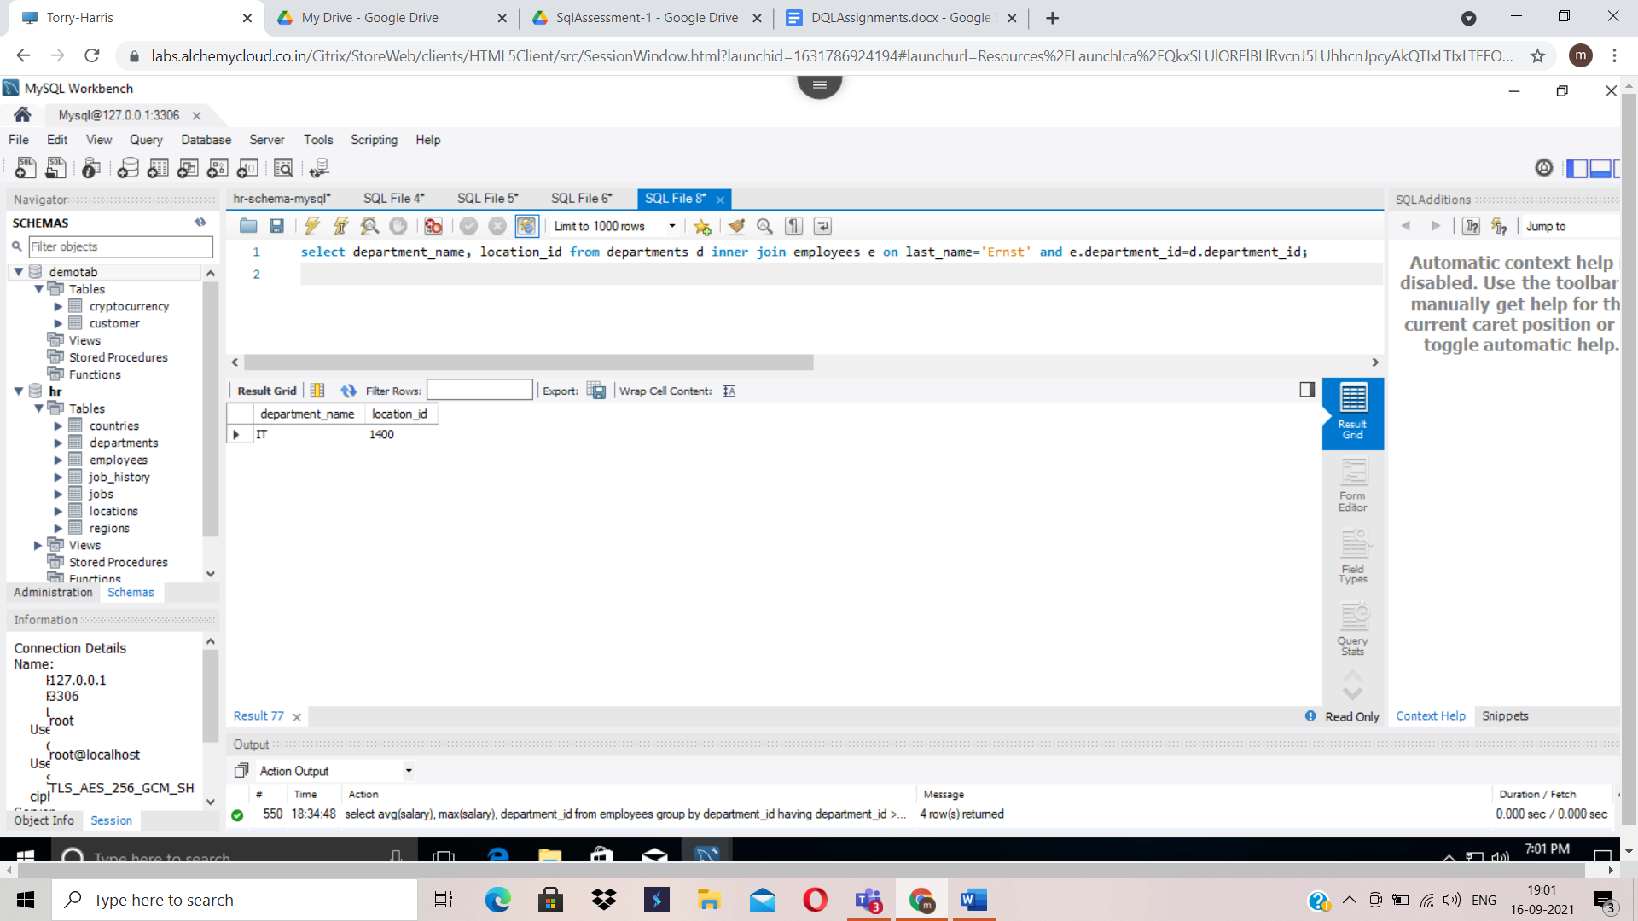

1. select e.first_name, e.last_name from employees e where department_id=(select d.department_id from departments d inner join locations l on l.location_id=d.location_id where l.city='Tokyo');

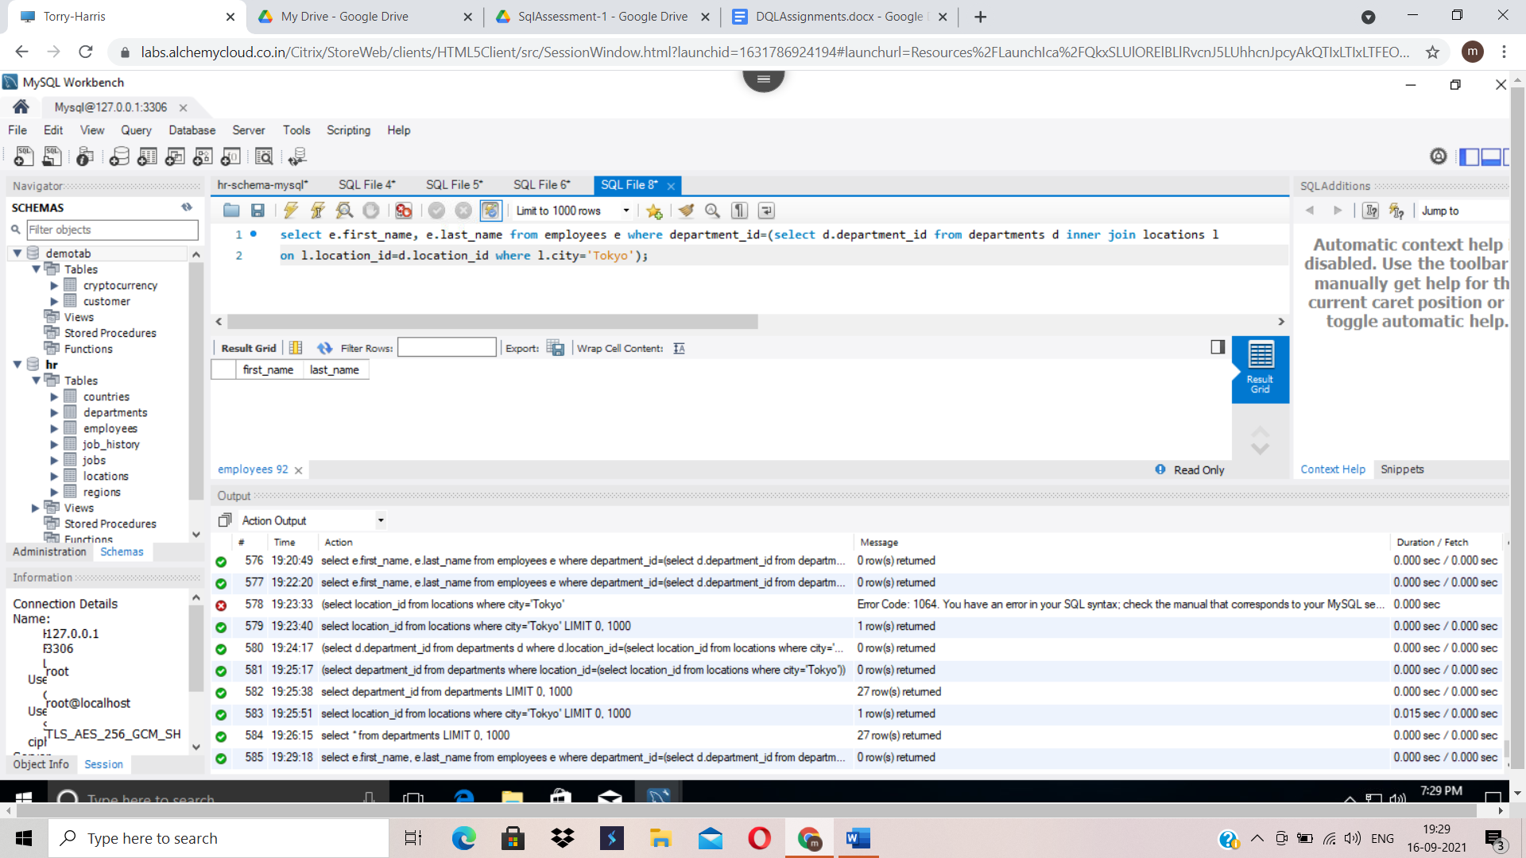

1. select first_name, last_name from employees where salary=(select max(salary) from employees);

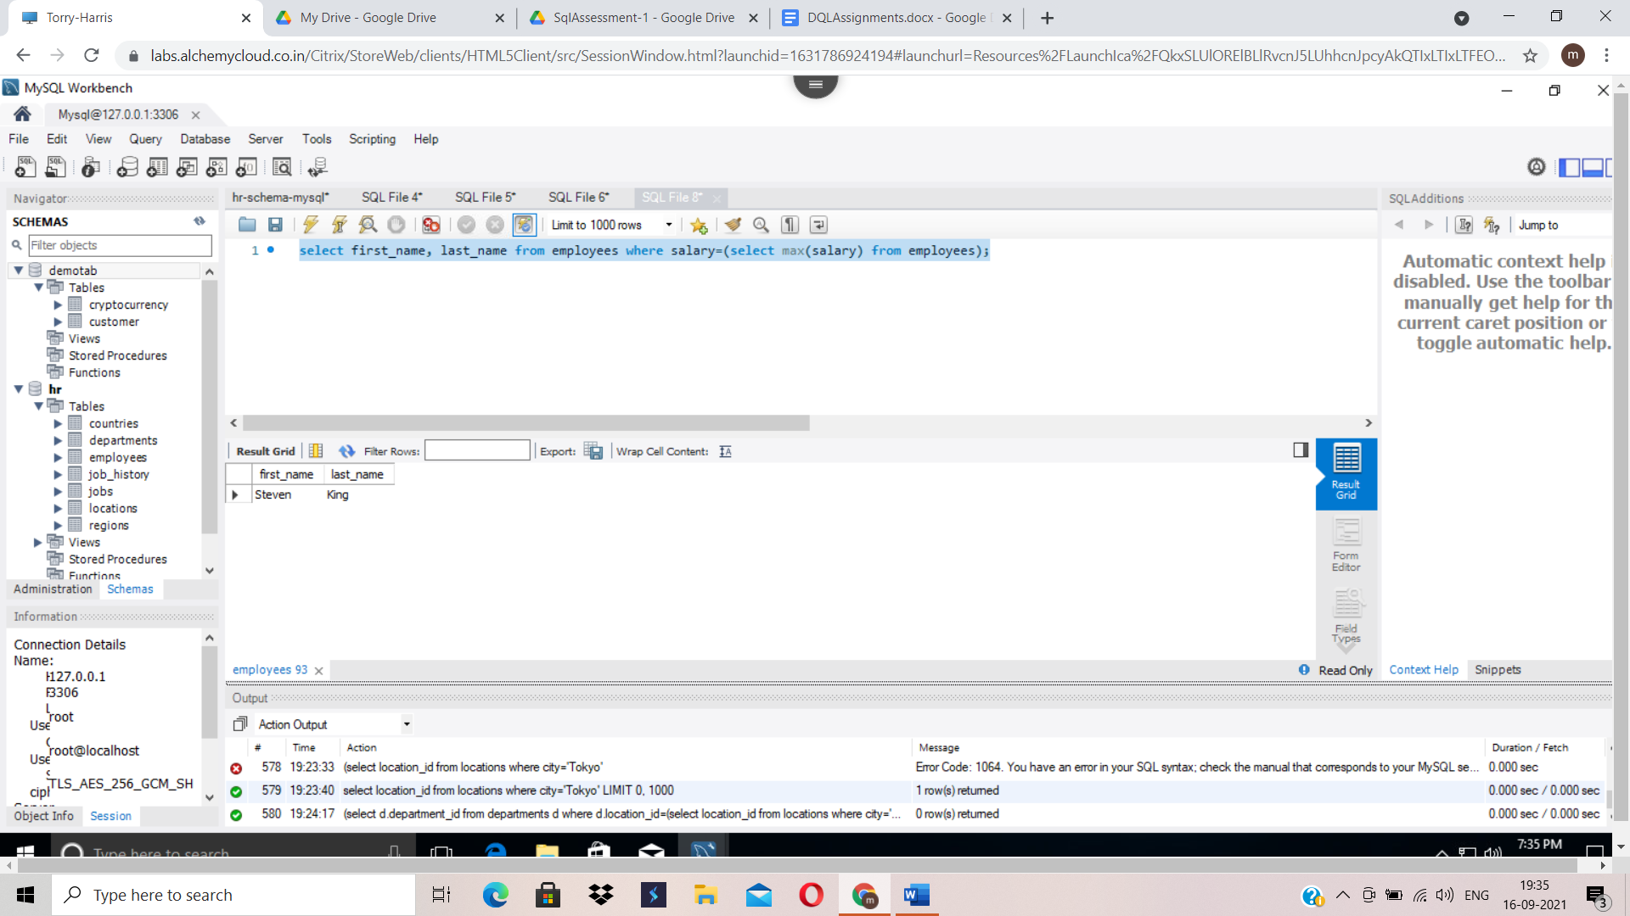

1. select first_name, last_name, e.job_id, j.job_title from employees e left outer join jobs j on j.job_id=e.job_id

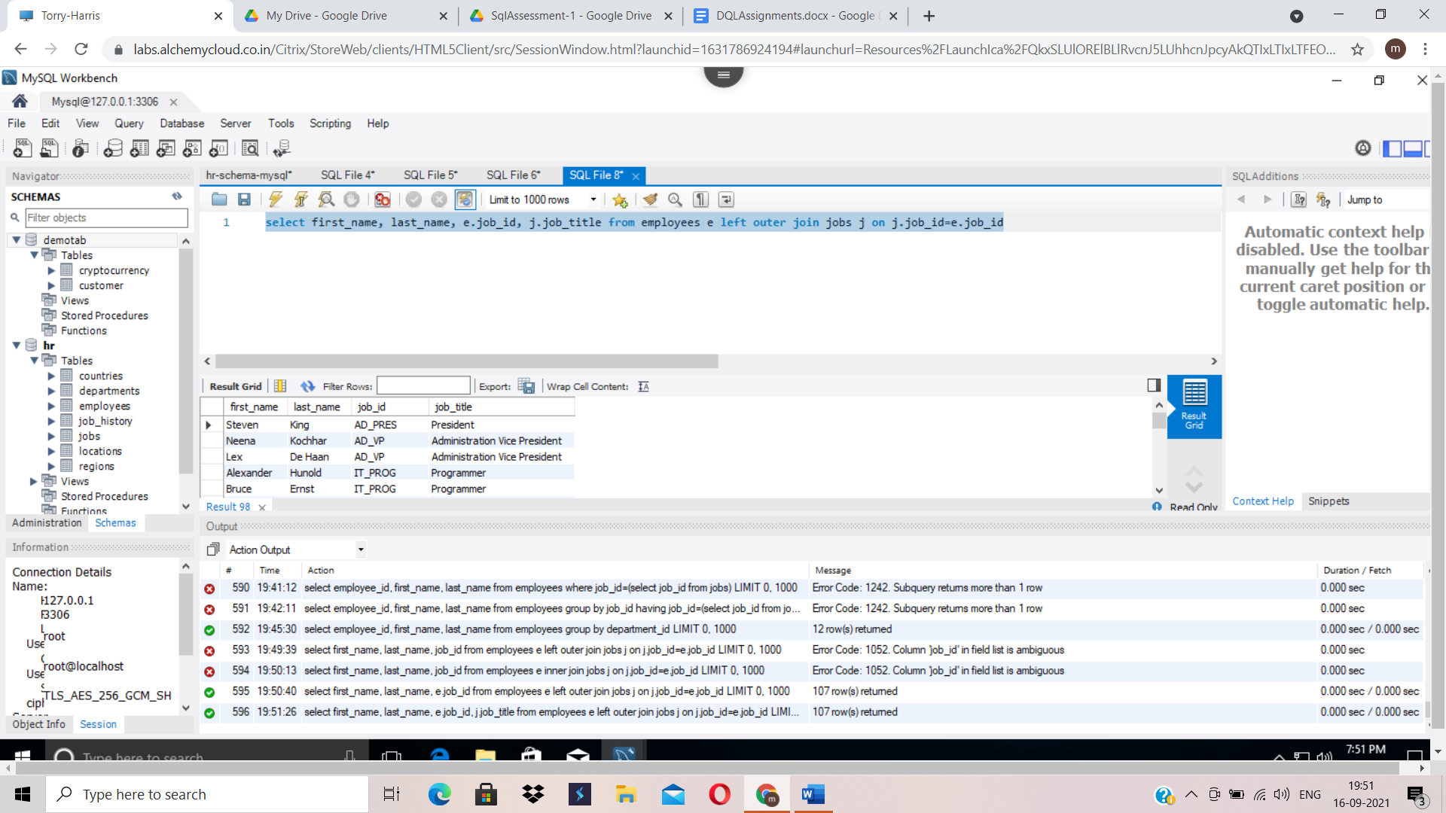

1. select first_name, last_name, department_id, j.min_salary from employees e inner join (select min_salary, job_id from jobs) as j on e.job_id=j.job_id;

